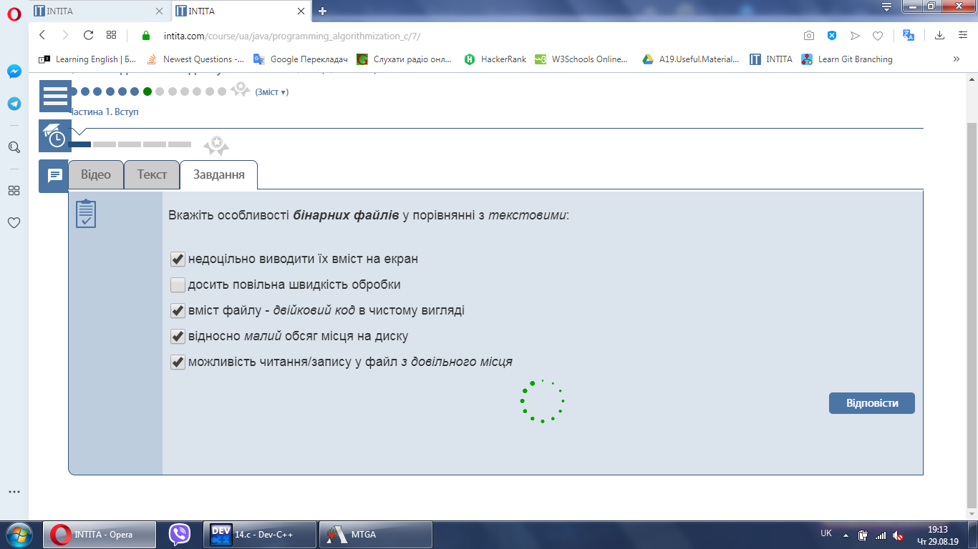


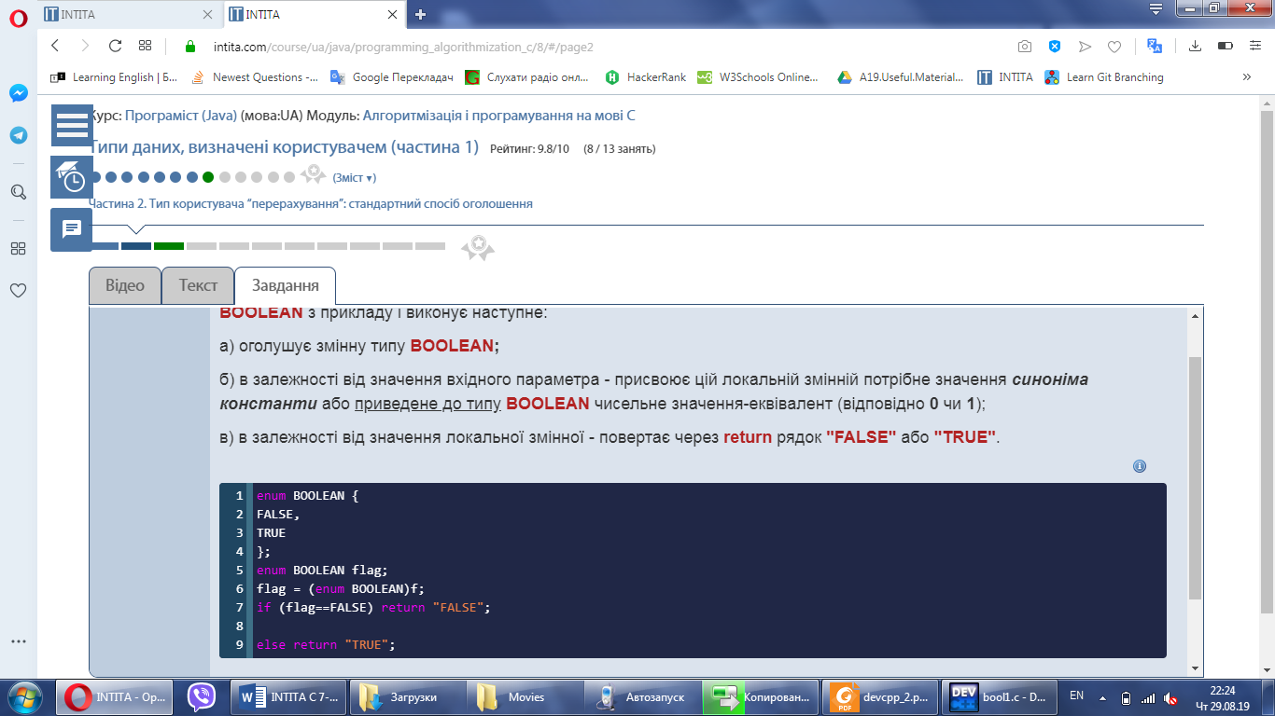
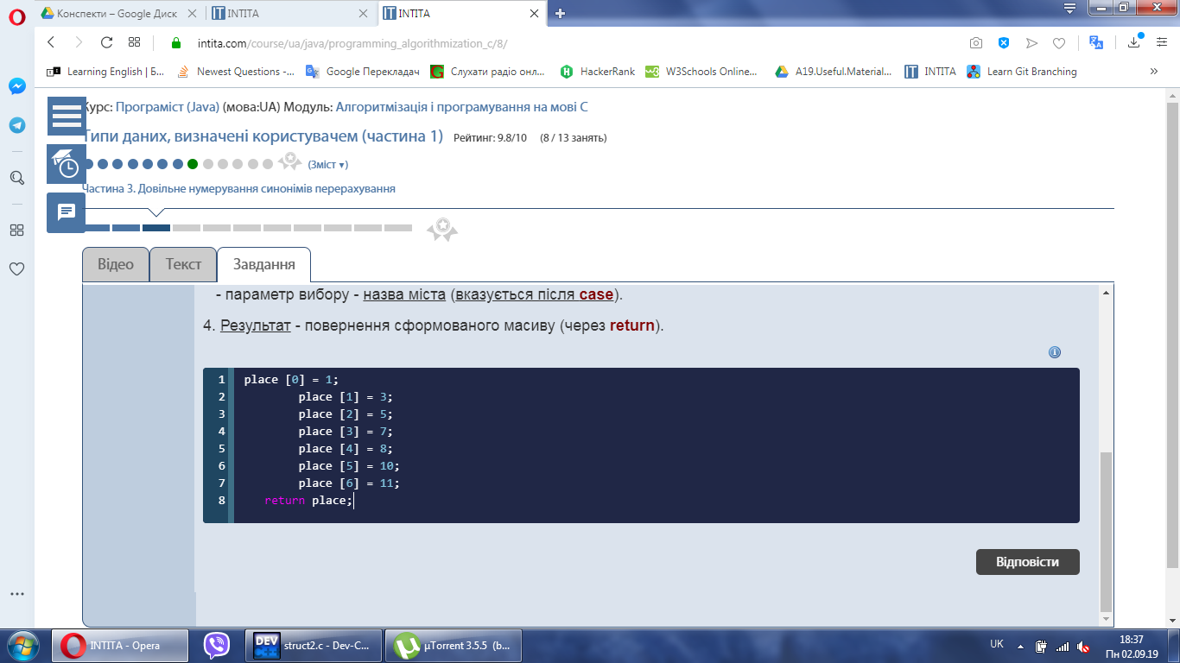

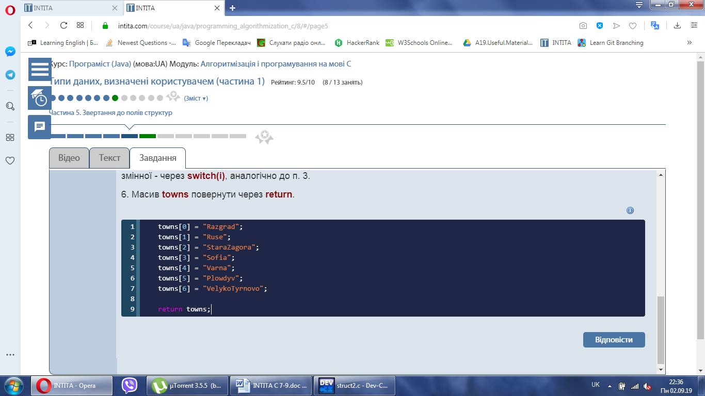
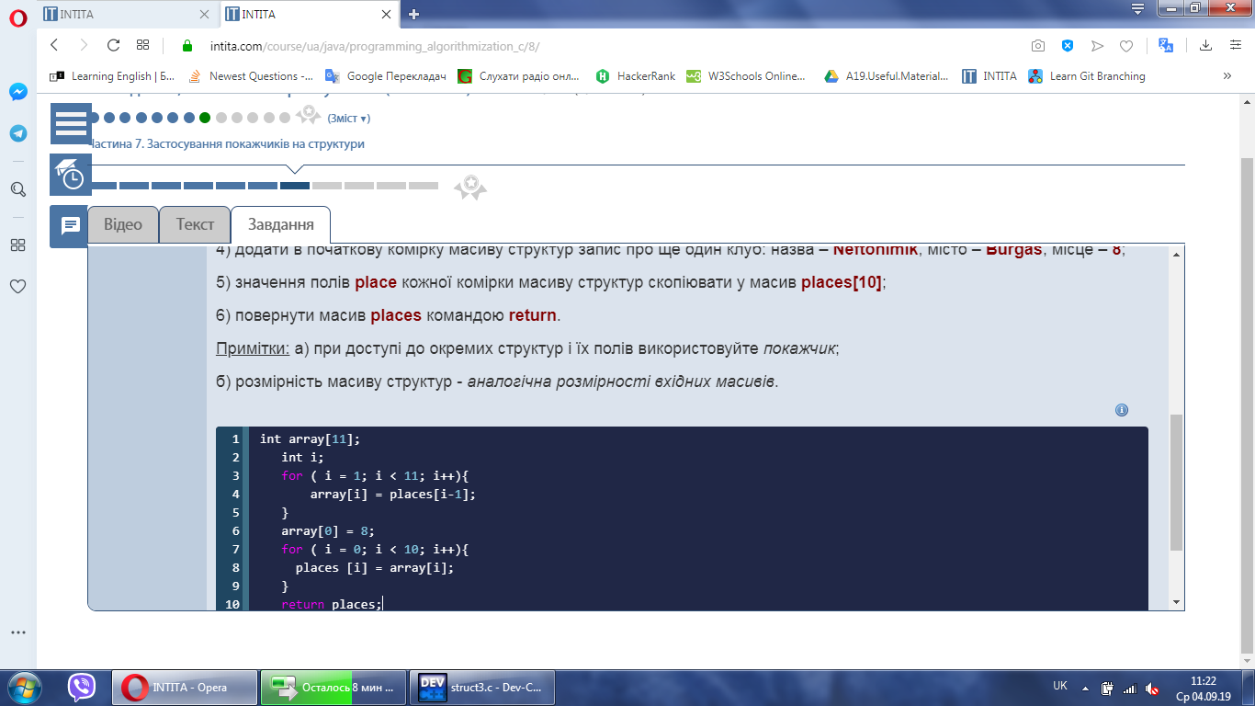
{
struct Club{
string name;
string city;
int place;
};
Club* A;
A = new Club [N];

int i, j;
for (i=0; i<N; i++){
A[i].name = teams[i];
A[i].city = towns[i];
A[i].place = places[i];
}
string *names;
names = new string [N];

for (i=0; i<N; i++){
for (j=0; j<N; j++){
if (A[j].place == i+1)
names[i] = A[j].name;
}
}
delete [ ] A;

return names;
}


